SECTION 1 – PRODUCT AND COMPANY INFORMATION

Product Identifiers
Product name: 5210 Anti-Foulant
Product Application: Reverse Osmosis System Cleaner
Emergency telephone number: CHEMTREC (800) 424-9300 Poison Control: 1-800-222-1222

SECTION 2 – HAZARD IDENTIFICATION

Classification of the substance or mixture
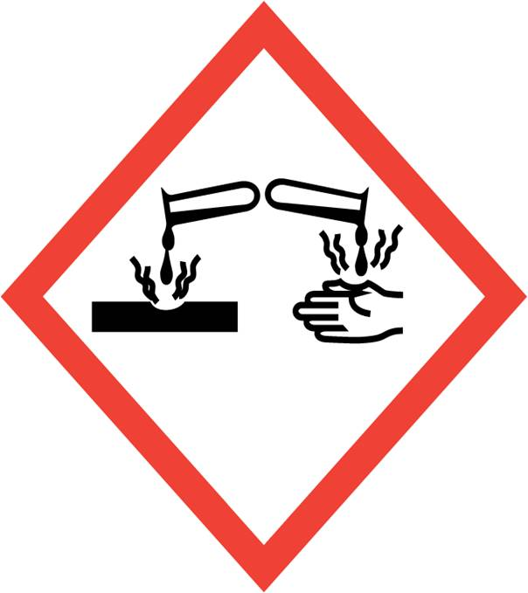
GHS Classification in accordance with 29 CFR 1910 (OSHA HCS)
Signal Word: DANGER
Pictograms: Corrosive
Physical Hazards: May be corrosive to metals
Health Hazards: Skin Irritation/Corrosion (Category 1) Causes severe skin burns.
Eye Damage/Irritation (Category 1) Causes severe skin burns and eye damage.
Precautionary Statements
Prevention: P234 Keep only in original container.
P260 Do not breathe mist, vapors or spray.
P264 Wash skin thoroughly after handling.
P271 Use only outdoors or in a well-ventilated area.
P280 Wear protective gloves/ eye protection/ face protection.
Response:
304 + P340 IF INHALED: Remove person to fresh air and
keep comfortable for breathing.
P305 + P351 + P338 IF IN EYES: Rinse cautiously with water
for several minutes. Remove contact lenses, if present and
easy to do. Continue rinsing.
P314 Get medical advice/ attention if you feel unwell.
P337 + P313 If eye irritation persists: Get medical advice/
attention.
P390 Absorb spillage to prevent material damage.
Disposal: P501 Dispose of contents/container in accordance with local regulation.

HNOC: HMIS Rating: Health hazard:3 Chronic Health Hazard: Flammability: 0 Physical Hazard 0
NFPA Rating: Health hazard: 3 Fire Hazard: 0 Reactivity Hazard: 0
* Hazards not otherwise classified (HNOC) or not covered by GHS.

SECTION 3 – COMPOSITION/INFORMATION ON INGREDIENTS

Hazardous Ingredient CAS Wt%
Potassium Hydroxide 1310-58-3 5-15%.
1-Hydroxyethylidene-1,1-diphosphonic acid 2809-21-4 1-3%

SECTION 4 – FIRST AID MEASURES

Description of first aid measures
General advice: Consult a physician. Show this safety data sheet to the doctor in attendance. Move out of dangerous area.
If inhaled: If breathed in, move person into fresh air. If not breathing, give artificial respiration. Consult a physician.
In case of skin contact: Take off contaminated clothing and shoes immediately. Wash off with soap and plenty of water. Consult a physician.
In case of eye contact: Rinse thoroughly with plenty of water for at least 15 minutes and consult a physician. Continue rinsing eyes during transport to hospital.
If swallowed: Do NOT induce vomiting. Never give anything by mouth to an unconscious person. Rinse mouth with water. Consult a physician.
Most important symptoms and effects, both acute and delayed: The most important known symptoms and effects are described in the labelling (see section 2) and/or in section 11
Indication of any immediate medical attention and special treatment needed: None known.

SECTION 5 – FIREFIGHTING MEASURES

Flammable Properties: Non-Flammable
Explosive Properties: N/A
Suitable Extinguishing media: N/A
Unsuitable extinguishing media: N/A
Special hazards arising from the substance or mixture: Overheating in fire conditions may produce POISONOUS GASES. Potassium Hydroxide in contact with water or moisture may generate enough heat to ignite combustibles.
Advice for firefighters: Wear self-contained breathing apparatus for firefighting if necessary.
Further information: If employees are expected to fight fires, they must be trained and equipped as stated in the OSHA Fire Brigades Standard (29 CFR 1910.156).

SECTION 6 – ACCIDENTIAL RELEASE MEASURES
Personal precautions, protective equipment and emergency procedures: Wear respiratory protection. Avoid dust formation. Avoid breathing vapor, mist or gas. Ensure adequate ventilation. Evacuate personnel to safe areas. For personal protection see Section 8.
Environmental precautions: Prevent further leakage or spillage if safe to do so. Do not let product enter drains. Discharge into the environment must be avoided.
Methods and materials for containment and cleaning up: Keep in suitable, closed containers for disposal.
Reference to other sections: For disposal see Section 13.
Product is water soluble and may be diluted and flushed as below described.
Other Information: This product is intended to be used in Reverse Osmosis system, and discharged to sanitary sewer in boiler blowdown water. Concentrated product may be diluted to a similar working concentration and flushed to sewer, or soaked up with absorbent material and landfilled in accordance with local, state, and federal regulations.

SECTION 7 – HANDLING AND STORAGE
Precautions for safe handling: Avoid contact with skin and eyes. Avoid formation of aerosols. Provide appropriate exhaust ventilation. For precautions see Section 2.
Conditions for safe storage, including any incompatibilities: Keep container tightly closed in a dry and well-ventilated place. Store as a non-combustible, corrosive hazardous materials

SECTION 8 – EXPOSURE CONTROL AND PERSONAL PROTECTION
Control parameters
Component | CAS # | Value | Control Parameters | Basis
1-Hydroxyethylidene 1,1- | 2809-21-4 | Not Regulated
Potassium Hydroxide | 1310-58-3 | REL | 2 mg/m³ | Ceiling Limit Value
 |  | TLV | 2 mg/m³ | Ceiling Limit Value
Exposure controls
Appropriate engineering controls: Handle in accordance with good industrial hygiene and safety practice. Wash hands before breaks and at the end of workday.
Personal protective equipment
Eye/face protection: Face shield and safety glasses Use equipment for eye protection tested and approved under appropriate government standards such as NIOSH (US) or EN 166(EU).
Skin protection: Handle with gloves. Gloves must be inspected prior to use. Use proper glove removal technique (without touching glove's outer surface) to avoid skin contact with this product.
Respiratory protection: Where risk assessment shows air-purifying respirators are appropriate use a full-face particle respirator type N100 (US) or type P3 (EN 143) respirator cartridges as a backup to engineering controls. If the respirator is the sole means of protection, use a full-face supplied air respirator. Use respirators and components tested and
approved under appropriate government standards such as NIOSH (US) or CEN (EU).
Control of environmental exposure: Prevent further leakage or spillage if safe to do so. Do not let product enter drains. Discharge into the environment must be avoided.

SECTION 9 – PHYSICAL AND CHEMICAL PROPERTIES
Appearance: Dark amber liquid with woody odor
pH: 7
Specific Gravity: 1.068
Molecular Weight: Mixture
Water Solubility: Complete
Melt/Freeze Point: Not Determined
Boiling Point: 110 C / 230 F
Flammability: Not Flammable
Flash Point: N/A
Vapor Density: NA
Note: Physical Data is typical values based on material tested, but may vary based on composition. Values should not be accepted as guaranteed for every lot or as specifications for this product.

SECTION 10 – STABILITY AND REACTIVITY

Reactivity: No data available
Chemical stability: Stable under normal conditions of use and storage
Possibility of hazardous reactions: No data available
Conditions to avoid: None known
Incompatible materials: Strong acids and oxidizers.
Hazardous decomposition products: None known.

SECTION 11 – TOXICOLOGICAL INFORMATION
Component: Potassium hydroxide CAS 1310-58-3
Acute Oral Toxicity | LD50 (Rat) 273 mg/kg
Acute inhalation toxicity | 80 mg/l (daphnia)
Acute Dermal Toxicity | No data available
Eye irritation | Strong irritant with the danger to cause serious eye injury, caused serious eye irritation
Target Organ Systemic Toxicant -Single exposure | Ingestion or inhalation will result in serious damage to affected membranes
Target Organ Systemic Toxicant - Repeated exposure | Routes of exposure: Inhalation May cause damage to organs through prolonged or repeated exposure.
Skin corrosion/irritation:
Respiratory or skin sensitization: | Stong caustic effect on skin
Reproductive toxicity: | No data available
Carcinogenicity | No component of this product present at levels greater than or equal to 0.1% is identified as a carcinogen or potential carcinogen by OSHA.
Aspiration hazard: | No data available
Germ cell mutagenicity: | No data available
Component: 1-Hydroxy Ethylidene 1,1 CAS 2809-21-4
Acute Oral Toxicity | LD50, Mouse, 1800. MG/KG.
Acute inhalation toxicity | No data available
Acute Dermal Toxicity | LD50 Dermal - Rat - 7000 mg/kg
Eye irritation | Strong irritant with the danger to cause serious eye injury, caused serious eye irritation
Target Organ Systemic Toxicant -Single exposure | Injestion or inhalation will result in serious damage to affected membranes
Target Organ Systemic Toxicant - Repeated exposure | Routes of exposure: Inhalation May cause damage to organs through prolonged or repeated exposure.
Skin corrosion/irritation: | Can cause irritation to the skin.
Ingestion: | May be harmful if swallowed. Can cause slight irritation and discomfort.
Respiratory or skin sensitization: | No data available
Reproductive toxicity: | No data available
Carcinogenicity | No component of this product present at levels greater than or equal to 0.1% is identified as a carcinogen or potential carcinogen by OSHA.
Aspiration hazard: | May be harmful if inhaled. Can cause irritation to the respiratory tract and can induce coughing.
Germ cell mutagenicity: | No data available

SECTION 12 – ECOLOGICAL INFORMATION

Component: Potassium hydroxide CAS 1310-58-3
Toxicity, Fish | 80 mg/l 96H
Toxicity, invertebrates | 60 mg/l 48H
Toxicity, Algae | ErC50 61 mg/l 96H
Bioaccumulation | This material will not bioconcentrate
Mobility | No data available
Biodegradability | This Material will disassociate into ionic form in the aquatic enviroment . Natural carbon dioxide will slowly neutralize this material
Biochemical OxygenDemand (BOD) | No data available
Other adverse effects: | No data available
Component: 1-Hydroxy Ethylidene 1,1 CAS 2809-21-4
Toxicity, Fish | Rainbow Trout (Oncorhynchus mykiss), 368.0 MG/L, 96 H.
Toxicity, invertebrates | Water Flea (Daphnia magna), 527.0 MG/L, 48 H.
Toxicity, Algae
Bioaccumulation | This material is not expected to bio-accumulate.
Mobility | Accidental spillage may lead to penetration in the soil and groundwater. However, there  is no evidence that this would cause adverse ecological effects.
Biodegradability | Degrades after acclimatization.
Biochemical OxygenDemand (BOD) | No data available
Other adverse effects: | No data available

SECTION 13 – DISPOSAL CONSIDERATION

Waste treatment methods:
Offer surplus and non-recyclable solutions to a licensed disposal company. Contact a licensed professional waste disposal service to dispose of this material. Dissolve or mix the material with a combustible solvent and burn in a chemical incinerator equipped with an afterburner and scrubber.
Contaminated packaging: Dispose of as unused product.
This product is intended to be used in pretreatment of boiler water, and discharged to sanitary sewer in boiler blowdown water. Concentrated product may be diluted to a similar working concentration and flushed to sewer, or soaked up with absorbent material and landfilled in accordance with local, state, and federal regulations.

SECTION 14 – TRANSPORT INFORMATION (USDOT)

Proper shipping Name: Non Hazardous Water Treatment Chemical
Hazard Class: NONE
UN/ID No NONE
Packing Group II
Reportable Quantity (RQ) N/A
Description: N/A

,

SECTION 15 – REGULATORY INFORMATION

TSCA (Toxic Substance Control Act): Components of this product are listed on the TSCA Inventory.
DSL: This product, or its components, are listed on or are exempt from the Canadian Domestic Substances List (DSL).
CERCLA: (Comprehensive Emergency Response Compensation, and Liability Act): Product is not found in “List of Hazardous Substances and Reportable Quantities” (40 CFR 302.4): None
RCRA: (Resource Conservation/Recovery Act): No
SARA 302 Components: No chemicals in this material are subject to the reporting requirements of SARA Title III, Section 302.
SARA 313 Components: This material does not contain any chemical components with known CAS numbers that exceed the threshold (De Minimis) reporting levels established by SARA Title III, Section 313.
SARA 311/312 Hazards: Acute Health Hazard
STATES: Massachusetts Right to Know Components, Pennsylvania Right To Know Components, New Jersey Right To Know Components: Potassium hydroxide CAS-No.1310-58-3
California Prop. 65 Components: This product does not contain any chemicals known to State of California to cause cancer, birth defects, or any other reproductive harm.

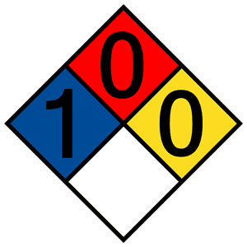
SECTION 16 – OTHER INFORMATION

Fire Protection Association (NFPA) Ratings:

NSF Certification: N/A

This Safety Data Sheet compiled from information provided by the raw chemical product manufacturers.

Disclaimer: The information presented herein is based on data considered to be accurate as of the date of preparation of this Safety Data Sheet. However, no warranty or representation, expressed or implied, is made as to the accuracy or completeness of the foregoing data and safety information, nor is any authorization given or implied to practice any patented invention without a license. In addition, no responsibility can be assumed by the vendor for any damage or injury resulting from abnormal use, from failure to adhere to recommended practices, or from any hazards inherent in the nature of the product.

